Name___________________________________

Quick Quiz

**Unit Rate 9**

Identify the unit rate:

1. work 40 hours in 5 days 2.

**_________ hours per day unit rate =_________**

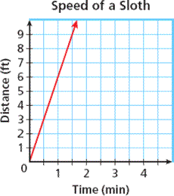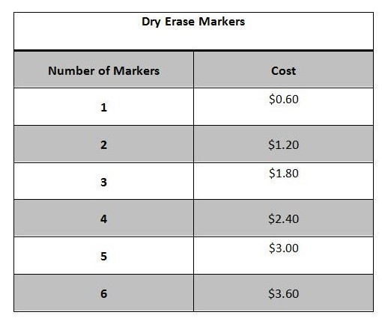

3. 4.  **________**

**$________ feet per per marker minute**

____________________________________________________________________________

Corrections

**Unit Rate 9**

Identify the unit rate:

1. work 40 hours in 5 days 2.

**_________ hours per day unit rate =_________**



3. 4.  **________**

**$________ feet per per marker minute**